

Thank you for taking the time to thank your nurse!

Your Name_________________________

Phone ____________________________

Email __________

❒ Please contact me if my nurse is chosen as a DAISY Honoree so that I may attend the celebration if available.

I am (please check one): ❒ RN ❒ MD ❒ Patient ❒ Family/Visitor ❒ Staff ❒ Volunteer

Date of nomination _________________

If you have any questions, please contact: _________________________________.

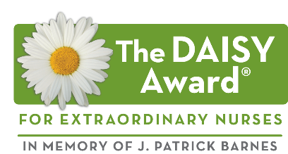

Each DAISY Award Honoree will be recognized at a public ceremony in her/his unit and will receive: a beautiful certificate, a DAISY Award pin, and a hand-carved stone sculpture entitled A Healer’s Touch. Additionally, everyone in the unit will celebrate with cinnamon rolls – a favorite of Patrick’s during his illness. The Barnes Family asks that whenever and wherever nurses smell that wonderful cinnamon aroma, they stop for a moment and think about how special they are.

© DAISY Foundation 2016

**Want to Say**

**Thank You**

**To Your Nurse?**

**Share *Your* Story!**

Memorial Hospital and Manor

Attn: Deborah Brown

1500 E Shotwell St

Bainbridge, GA 39819

The DAISY (Diseases Attacking the Immune SYstem) Award is an international recognition program that honors and celebrates the skillful, compassionate care nurses provide every day. The DAISY Foundation was established by the family of J. Patrick Barnes after he died from complications of the auto-immune disease ITP in 1999. During his hospitalization, they deeply appreciated the care and compassion shown to Patrick and his entire family. When he died, they felt compelled to say “thank you” to nurses in a very public way. Please say thank you by sharing your story of how a nurse made a difference you will never forget!





**The DAISY Award for Extraordinary Nurses**

**To Nominate an Extraordinary Nurse:**

Anyone may thank a deserving nurse by filling out this form and submitting it to __________________________­­­­­­­­­­___________.

Name of the nurse you are nominating:

Unit where this nurse works:

I would like to thank my nurse and share my story of why this nurse is so special: